**Batch:   C - 3 Roll No.: 1601022096**

**Experiment No. 2**

**Title:** Represent discrete time signals and perform different operations on them.

**Objective:** To familiarize the beginner to MATLAB by introducing the basic featuresand commands of the program.

**Expected Outcome of Experiment:**

|  |  |
| --- | --- |
| **CO** | **Outcome** |
|  |  |
| **CO1** | Identify various discrete time signals and systems and perform signal |
| manipulation |
|  |
|  |  |

**Books/ Journals/ Websites referred:**

1. A.Nagoor Kani “Digital Signal Processing”, 2nd Edition, TMH Education.

**Pre Lab/ Prior Concepts:**

In digital signal processing, discrete-time signals are defined at specific intervals. MATLAB provides powerful tools for creating, manipulating, and analyzing such signals using functions like stem, plot, and mathematical operations such as scaling, shifting, folding, addition, and multiplication.

**Discrete time signals types:**

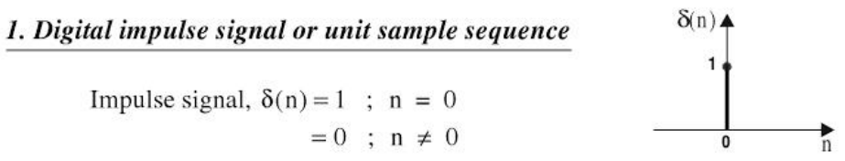

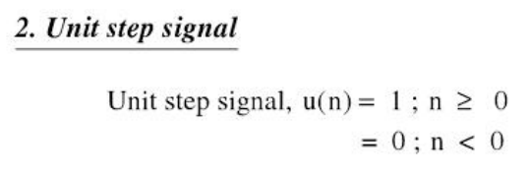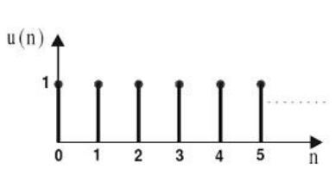

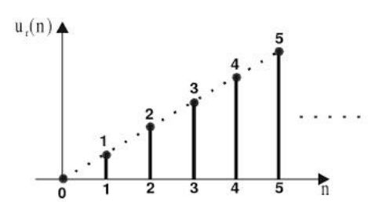

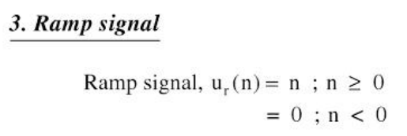

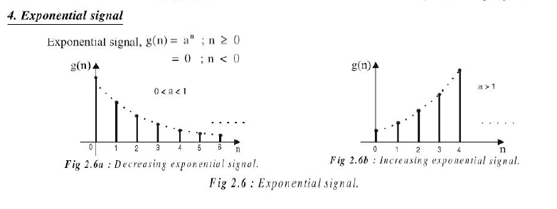

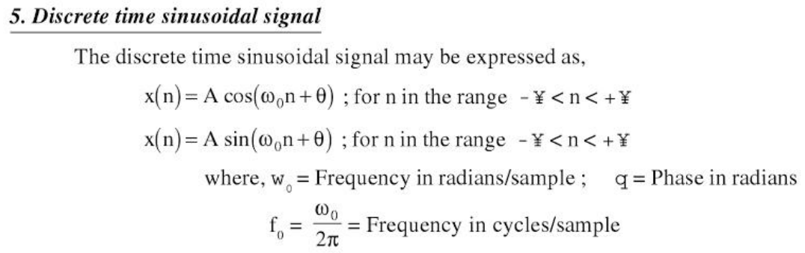

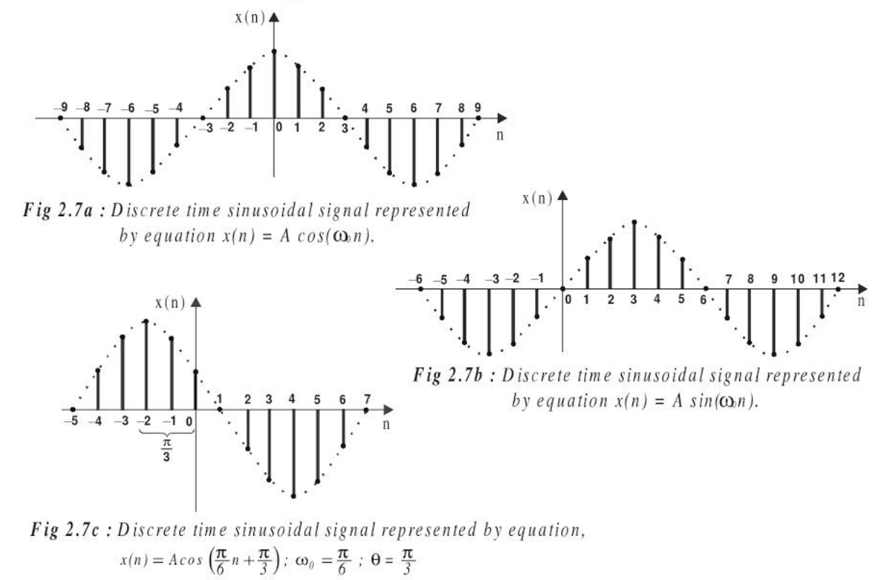

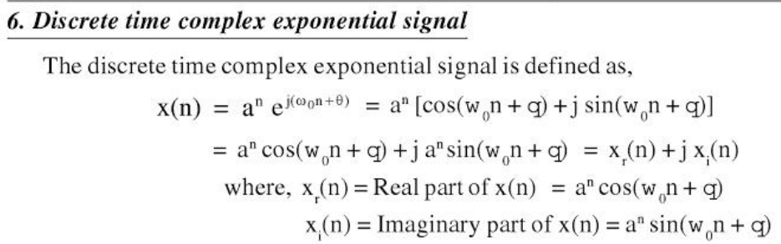

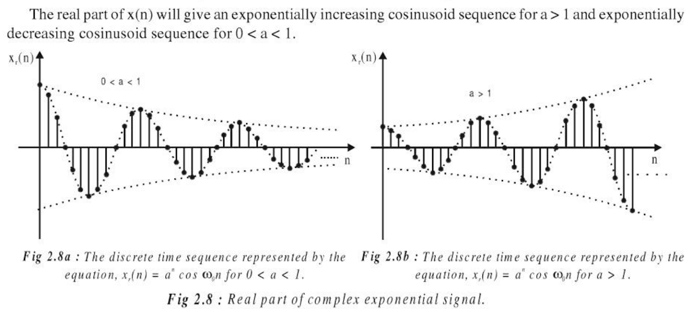

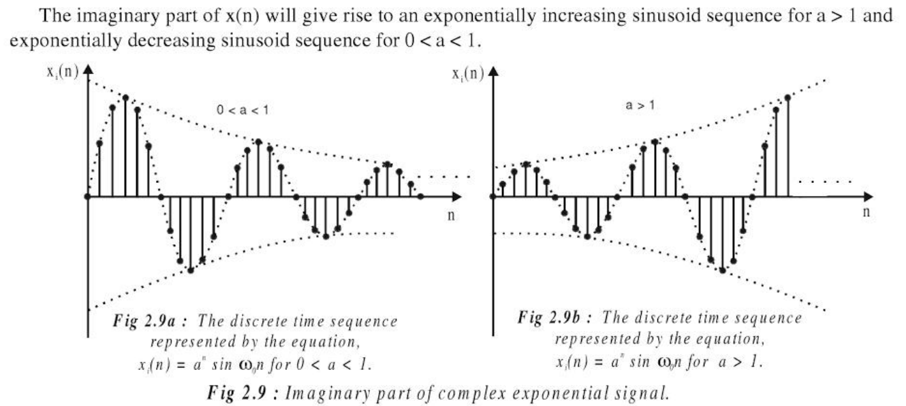

**Discrete Signals:**n = -10:10;

impulse = (n == 0);

unit_step = (n >= 0);

ramp = n .* (n >= 0);

a = 0.9;

exponential = a.^n;

omega = pi/4;

sinusoidal = sin(omega * n);

complex_exponential = exp(1j * omega * n);

figure;

subplot(3, 2, 1);

stem(n, impulse, 'filled');

title('Impulse Signal (delta[n])');

xlabel('n');

ylabel('Amplitude');

subplot(3, 2, 2);

stem(n, unit_step, 'filled');

title('Unit Step Signal (u[n])');

xlabel('n');

ylabel('Amplitude');

subplot(3, 2, 3);

stem(n, ramp, 'filled');

title('Ramp Signal (r[n])');

xlabel('n');

ylabel('Amplitude');

subplot(3, 2, 4);

stem(n, exponential, 'filled');

title('Exponential Signal (a^n)');

xlabel('n');

ylabel('Amplitude');

subplot(3, 2, 5);

stem(n, sinusoidal, 'filled');

title('Discrete Sinusoidal Signal (sin(\omega n))');

xlabel('n');

ylabel('Amplitude');

subplot(3, 2, 6);

stem(n, real(complex_exponential), 'filled');

title('Discrete-Time Complex Exponential Signal (exp(j\omega n))');

xlabel('n');

ylabel('Amplitude');

**OUTPUT:**

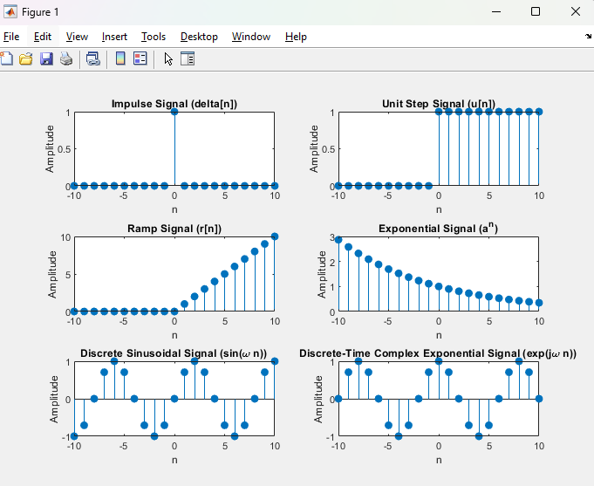

**Operations on Signals:**

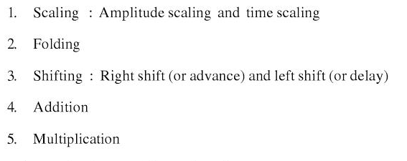

**1] Scaling:**

n = -10:10;

random_signal = (rand(1, length(n)) * 8) - 4; % Random values between -4 and 4

figure;

subplot(2, 1, 1);

stem(n, random_signal, 'filled');

title('Original Random Signal');

xlabel('n');

ylabel('Amplitude');

scaled_signal = 2 * random_signal;

subplot(2, 1, 2);

stem(n, scaled_signal, 'filled');

title('Scaled Random Signal (by 2)');

xlabel('n');

ylabel('Amplitude');

**OUTPUT:**

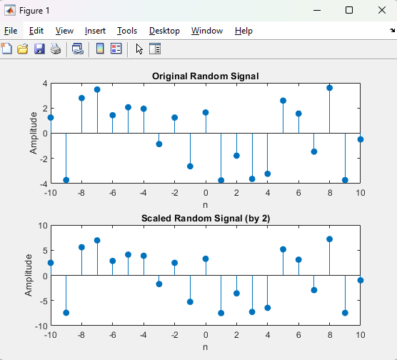

**2] Folding:**

n = -10:10;

random_signal = (rand(1, length(n)) * 8) - 4;

figure;

subplot(2, 1, 1);

stem(n, random_signal, 'filled');

title('Original Random Signal');

xlabel('n');

ylabel('Amplitude');

folded_signal = fliplr(random_signal);

subplot(2, 1, 2);

stem(n, folded_signal, 'filled');

title('Folded Random Signal (Time Reversal)');

xlabel('n');

ylabel('Amplitude');

**OUTPUT:**

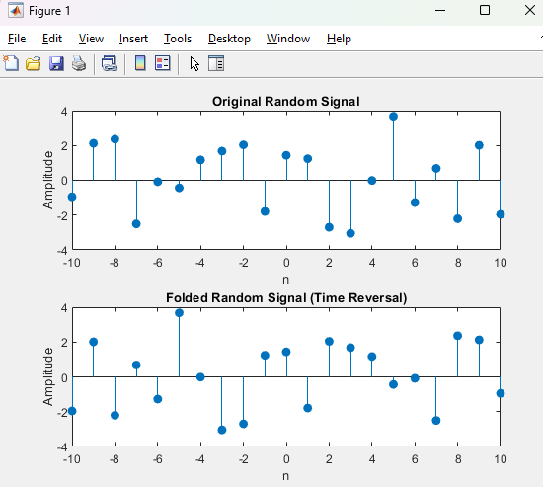

**3] Shifting:**

n = -10:10;

random_signal = (rand(1, length(n)) * 8) - 4;

figure;

subplot(3, 1, 1);

stem(n, random_signal, 'filled');

title('Original Random Signal');

xlabel('n');

ylabel('Amplitude');

right_shifted_signal = [zeros(1, 3), random_signal(1:end-3)];

subplot(3, 1, 2);

stem(n, right_shifted_signal, 'filled');

title('Right Shifted Random Signal (by 3 units)');

xlabel('n');

ylabel('Amplitude');

left_shifted_signal = [random_signal(4:end), zeros(1, 3)];

subplot(3, 1, 3);

stem(n, left_shifted_signal, 'filled');

title('Left Shifted Random Signal (by 3 units)');

xlabel('n');

ylabel('Amplitude');

**OUTPUT:**

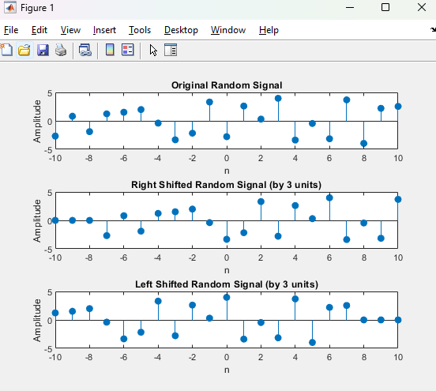

**4] Addition:**

n = -10:10;

random_signal1 = (rand(1, length(n)) * 8) - 4;

random_signal2 = (rand(1, length(n)) * 8) - 4;

figure;

subplot(3, 1, 1);

stem(n, random_signal1, 'filled', 'r');

title('Original Random Signal 1');

xlabel('n');

ylabel('Amplitude');

subplot(3, 1, 2);

stem(n, random_signal2, 'filled', 'b');

title('Original Random Signal 2');

xlabel('n');

ylabel('Amplitude');

added_signals = random_signal1 + random_signal2;

subplot(3, 1, 3);

stem(n, added_signals, 'filled');

title('Added Random Signals');

xlabel('n');

ylabel('Amplitude');

**OUTPUT:**

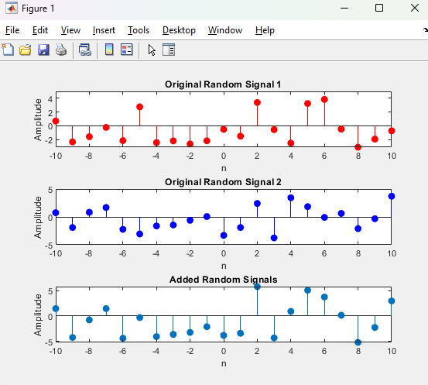

**5] Multiplication:**

n = -10:10;

random_signal1 = (rand(1, length(n)) * 8) - 4;

random_signal2 = (rand(1, length(n)) * 8) - 4;

figure;

subplot(3, 1, 1);

stem(n, random_signal1, 'filled', 'r');

title('Original Random Signal 1');

xlabel('n');

ylabel('Amplitude');

subplot(3, 1, 2);

stem(n, random_signal2, 'filled', 'b');

title('Original Random Signal 2');

xlabel('n');

ylabel('Amplitude');

multiplied_signals = random_signal1 .* random_signal2;

subplot(3, 1, 3);

stem(n, multiplied_signals, 'filled');

title('Multiplied Random Signals');

xlabel('n');

ylabel('Amplitude');

**OUTPUT:**

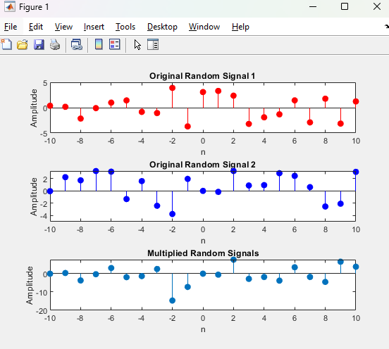

**Conclusion:-**

This experiment helped in understanding discrete-time signals and their manipulation using MATLAB, enhancing the ability to perform various operations on signals effectively.

**Post Lab Question:**

1. Let x(n) = 8(0.5)n (u[n+1] - u[n-3]). Sketch the following signals
2. Y(n) = [x-3]
3. F(n) = x[n+1]
4. G(n) = x[-n+4]

n = -10:10;

u = @(n) double(n >= 0);

x = @(n) 8*(0.5).^n .* (u(n+1) - u(n-3));

x_n = x(n);

Y_n = x(n - 3);

F_n = x(n + 1);

G_n = x(-n + 4);

figure;

subplot(4, 1, 1);

stem(n, x_n, 'filled');

title('Original Signal x(n)');

xlabel('n');

ylabel('Amplitude');

subplot(4, 1, 2);

stem(n, Y_n, 'filled');

title('Y(n) = x[n-3] (Right Shift by 3)');

xlabel('n');

ylabel('Amplitude');

subplot(4, 1, 3);

stem(n, F_n, 'filled');

title('F(n) = x[n+1] (Left Shift by 1)');

xlabel('n');

ylabel('Amplitude');

subplot(4, 1, 4);

stem(n, G_n, 'filled');

title('G(n) = x[-n+4] (Time Reversal and Right Shift by 4)');

xlabel('n');

ylabel('Amplitude');

**OUTPUT:**

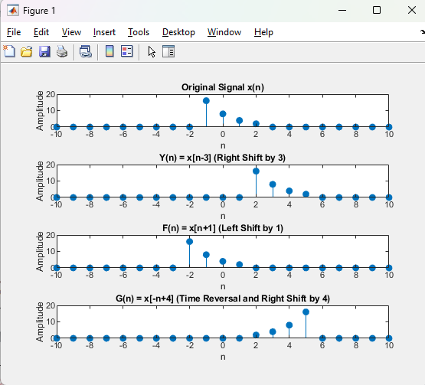

1. The process of conversion of continuous time signal into discrete time signal is known as **sampling**.
2. Which of the following is an example of a deterministic signal?
   * 1. Step
     2. Ramp
     3. Exponential
     4. **All of the above**
3. For energy signals the energy will be finite and the average power will be zero.
4. In a signal x(n), if ‘n’ is replaced by ‘n/3’ the it is called time scaling.
5. The system y(n)=sin[x(n)] is
   * 1. Stable
     2. **BIBO stable**
     3. Unstable
     4. None of the above